#293c56

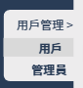 #edeced

 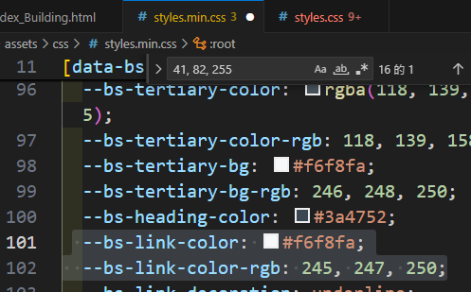

 --bs-link-color: #f6f8fa;

  --bs-link-color-rgb: 245, 247, 250;

 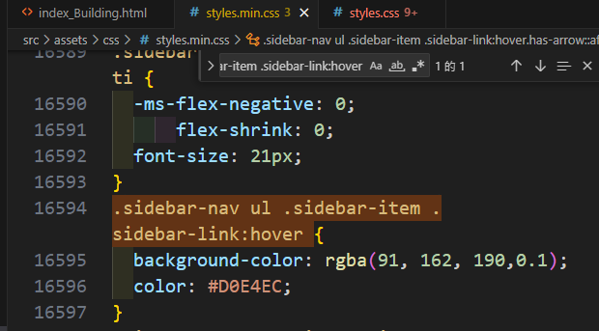

.sidebar-nav ul .sidebar-item .sidebar-link:hover {

  background-color: rgba(91, 162, 190,0.1);

  color: #D0E4EC;

}

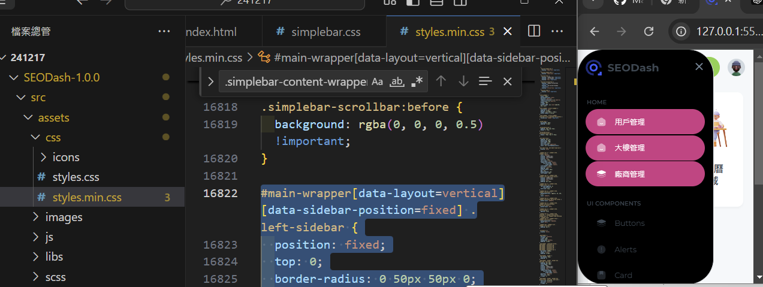

正常版本

#main-wrapper[data-layout=vertical][data-sidebar-position=fixed] .left-sidebar {

  position: fixed;

  top: 0;

  border-radius: 0 50px 50px 0;

  background-color: black;

}

縮小版本

  #main-wrapper[data-layout=vertical][data-sidebartype=mini-sidebar].show-sidebar .left-sidebar, #main-wrapper[data-layout=vertical][data-sidebartype=full].show-sidebar .left-sidebar {

    left: 0;

    border-radius: 50px;

  }

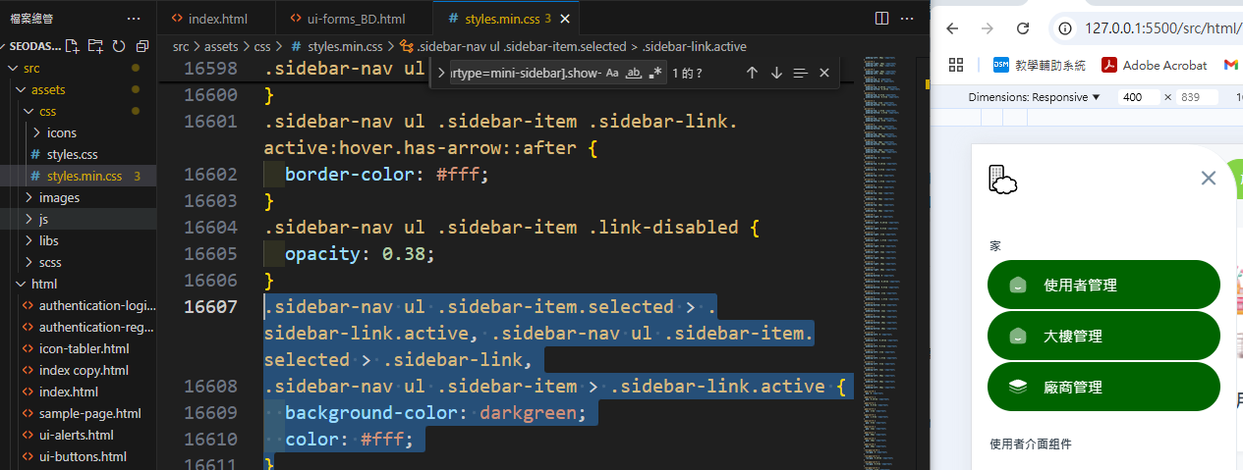

.sidebar-nav ul .sidebar-item.selected > .sidebar-link.active, .sidebar-nav ul .sidebar-item.selected > .sidebar-link,

.sidebar-nav ul .sidebar-item > .sidebar-link.active {

  background-color: darkgreen;

  color: #fff;

}

更換ICON的圖庫網址<https://icon-sets.iconify.design/>

版本參考<https://www.creative-tim.com/product/paper-dashboard>

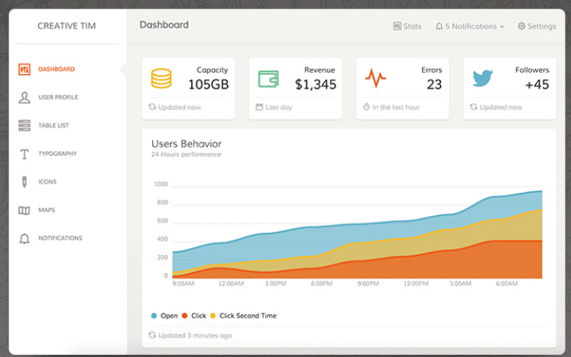

更換ICON的圖庫網址<https://fontawesome.com/v6/search?o=r&m=free>